**Installing and configuring SSRS (SQL 2019)**

**NB!!** If your customer is using the server as a Domain Controller, SSRS will NOT install. To get around this, try the following:

1. With customer’s permission, remove DC rule, install SSRS, and reapply DC rule
2. Customer to provide and alternative server / PC to run SSRS (must be within same network and be accessible from user’s PCs, i.e. can browse to the SSRS report url

If you have not already done so, install Microsoft SQL Server 2017 Reporting Services

To do this, either:

Run SQL 2017 Setup

Click Install SQL Server Reporting Services which will take you to the download link.

Close SQL Setup

OR

Go to

<https://www.microsoft.com/en-us/download/details.aspx?id=55252>

After the download has completed (About 90MB)

Open the file and click ***Install Reporting Services***

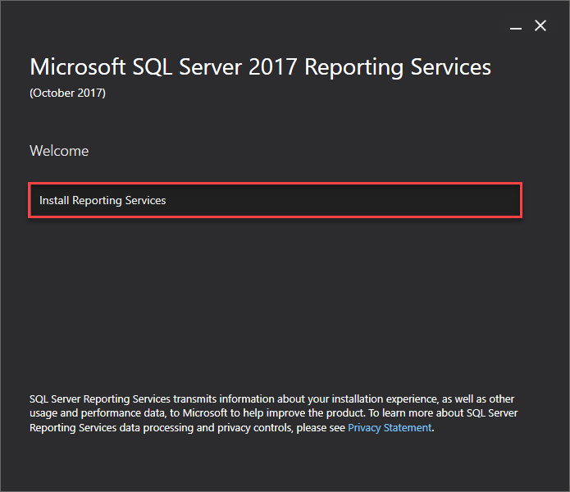

Choose Developer Edition from the dropdown and click ***NEXT***

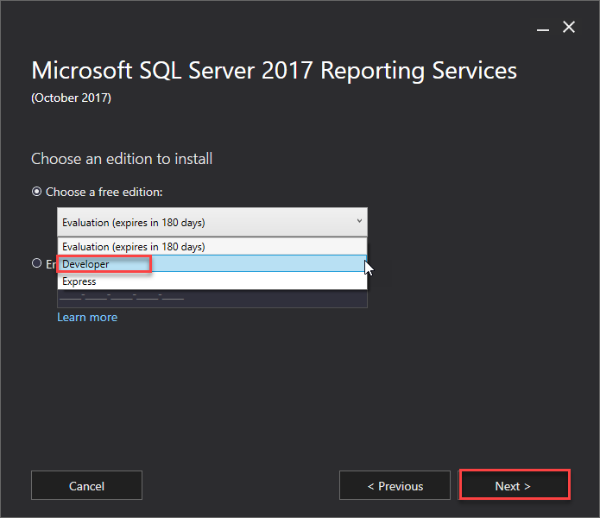

Check ***I Accept the License Terms*** and click ***NEXT***

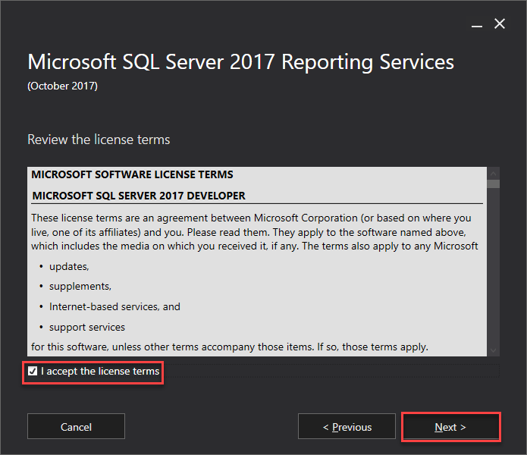

Click ***NEXT***

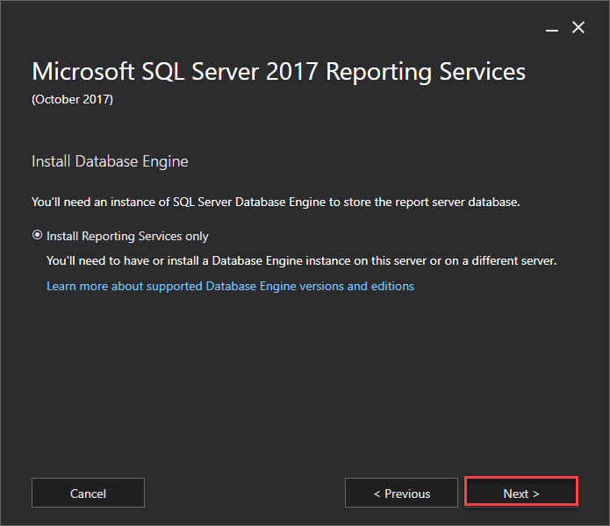

Click ***INSTALL***

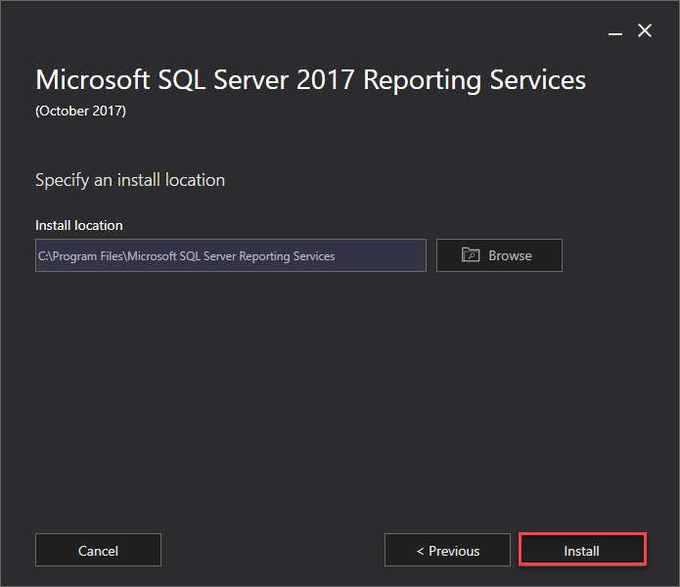

Click ***Configure Report Server***

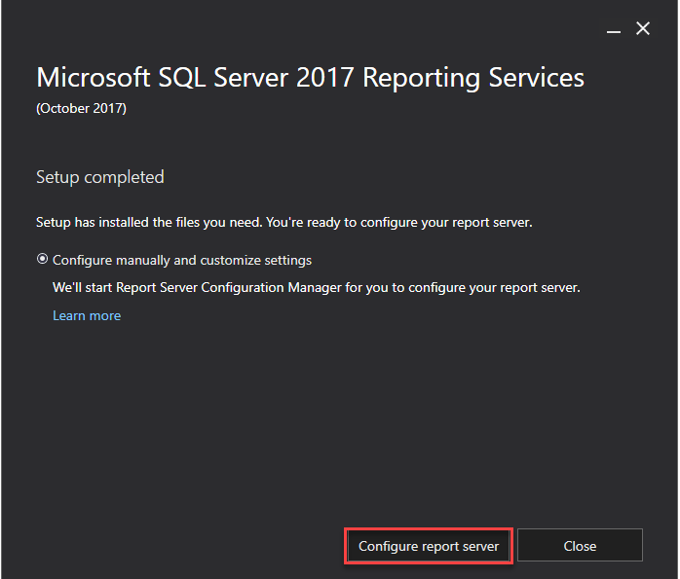

If required, specify your SQL Server name and click Connect

Once the Report Service has started, click Web Service URL

Leave the virtual directory as is

Change the port number if this port is already used in IIS.

Use the something in the same range as you use for the Granite Web Application

i.e. Granite 3400, Reporting Services 3401

Click ***APPLY***

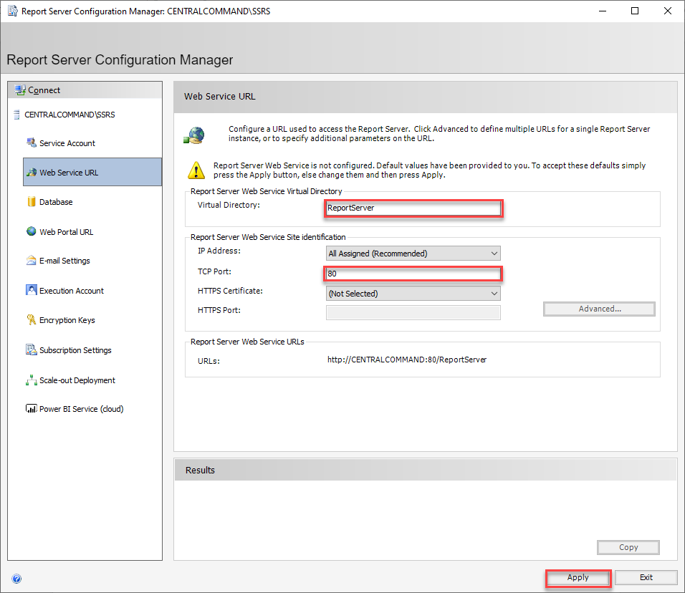

Wait for the Results window at the bottom

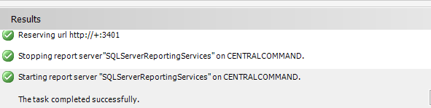

Click ***DATABASE***

Click ***Change Database***

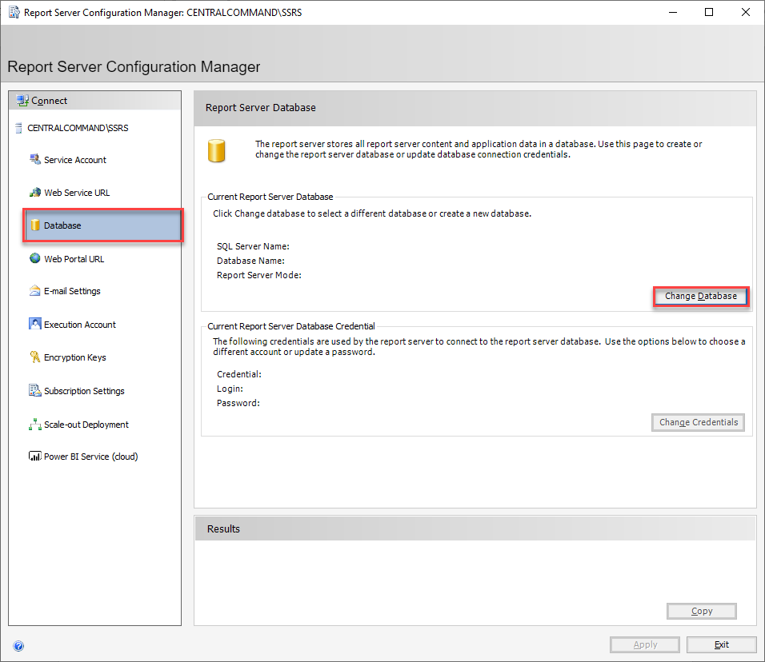

Click ***NEXT***

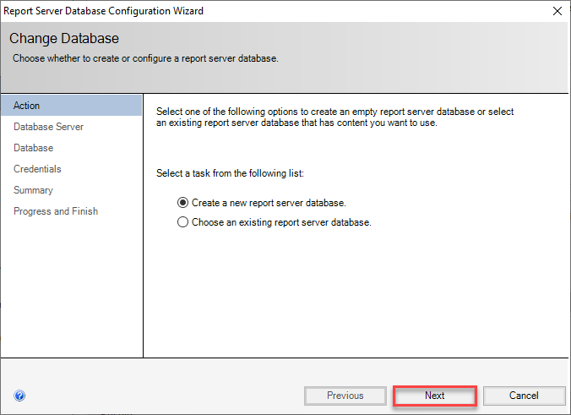

Specify your SQL Server Instance

Change Authentication Type to SQL Server Account

Enter SQL Username and Password

Click Test Connection

If all is in order, click ***NEXT***

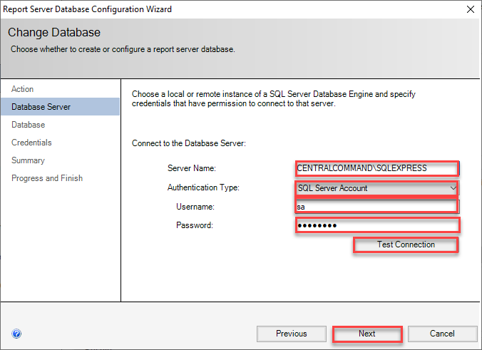

Click ***NEXT***

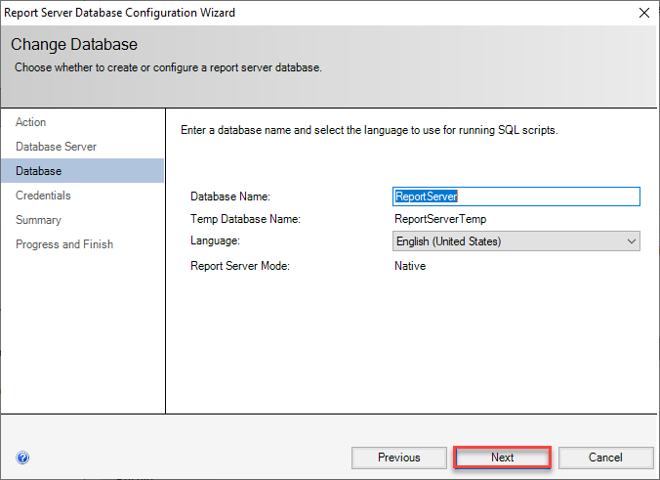

Change Authentication Type to SQL Server Credentials

Enter SQL Username and Password

Click ***NEXT***

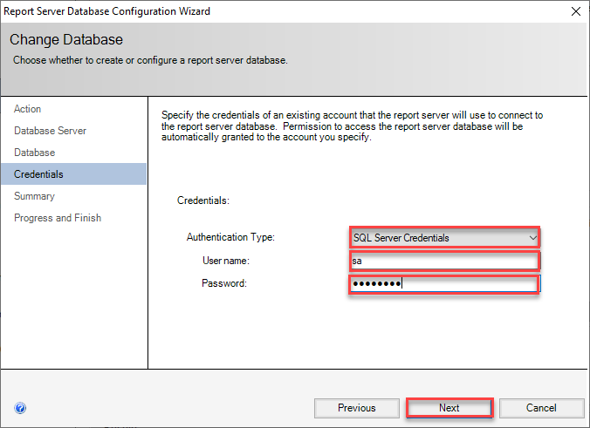

Click ***NEXT***

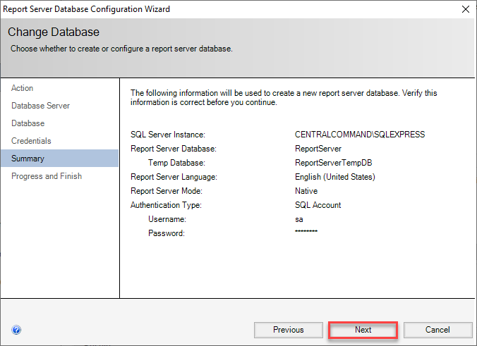

Click ***FINISH***

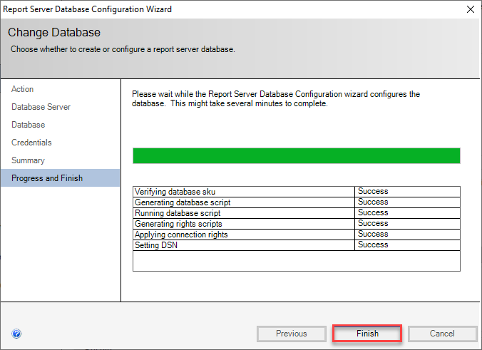

Click ***Web Portal URL***

Click ***APPLY***

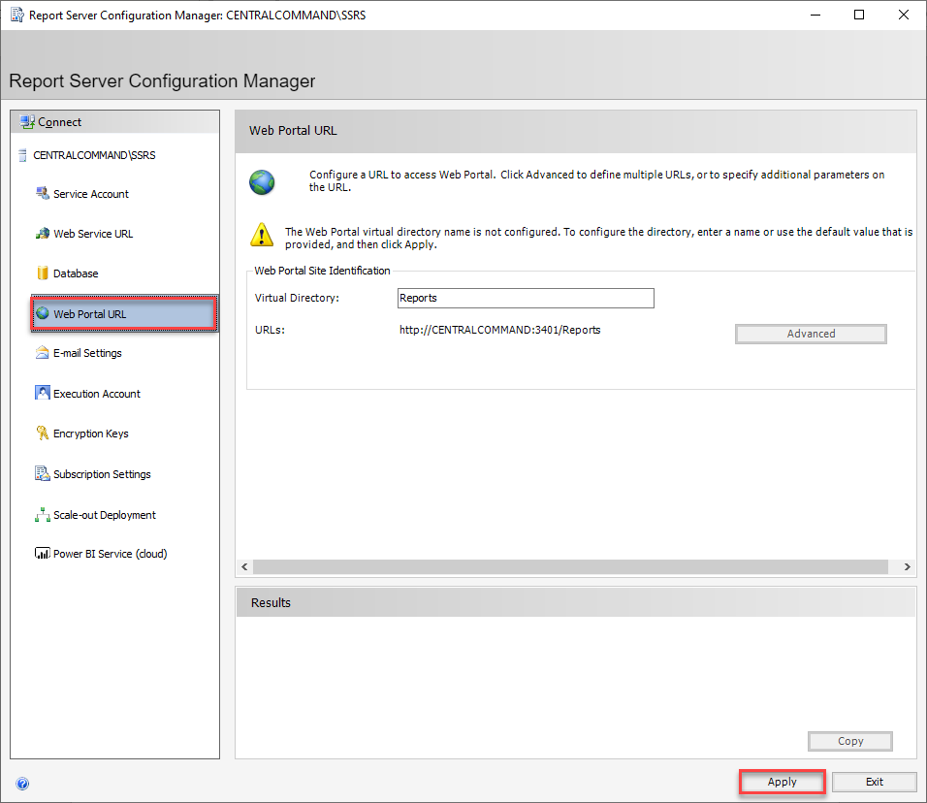

Test your setup by clicking the URL

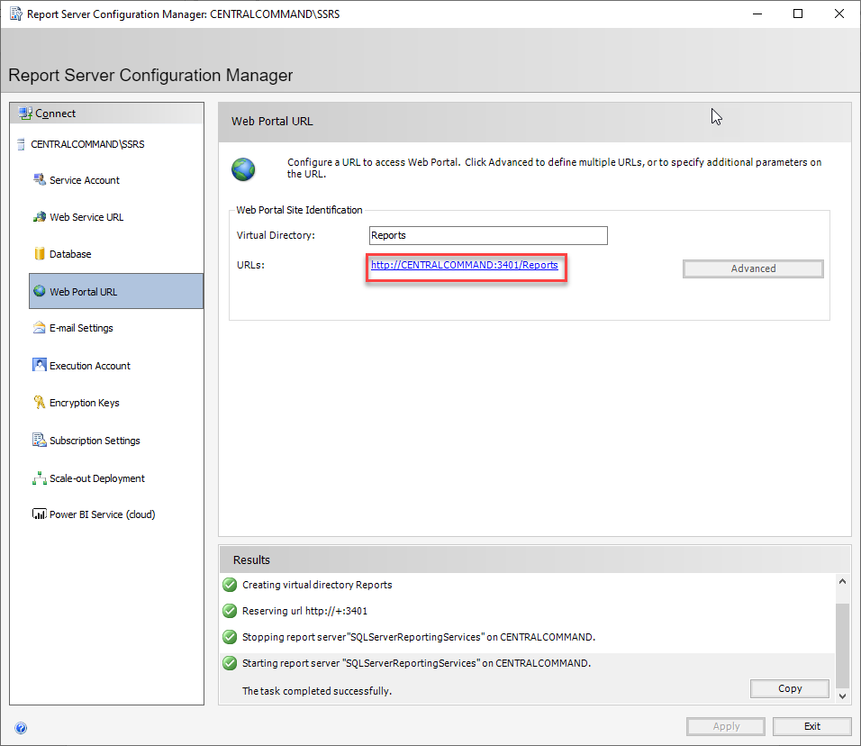

A similar webpage should open

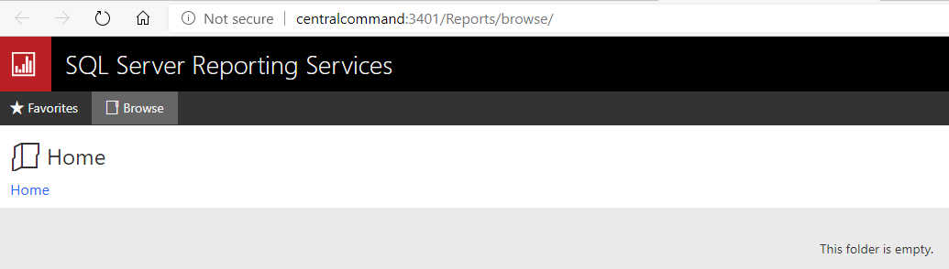

Exit SSRS Setup